ROTARY DISTRICT 6220
GLOBAL GRANT SCHOLARS (GGS) TESTIMONIALS

ROTARY GLOBAL GRANT SCHOLARSHIP RECIPIENTS’ EXPERIENCE AND IMPACT ON THEIR LIVES AND WORK:

Tracy Wilichowski (2014-2015 GGS)
GGS Rotary Area of Focus: Economic and Community Development
Place of Study: London School of Economics, London, United Kingdom
Studies & Degree: Master in Development Studies

From January to June 2017, I worked as a consultant for The World Bank Group in Washington, DC. As part of my role in the Education Global Practice, I support both analytical and operational activities related to teacher practices and behavior, basic education, and service delivery in developing countries. Specifically, I aid in coordination and application of Systems Approach for Better Education Results (SABER) tools. SABER uses diagnostic tools and detailed policy information to collect and analyze comparative data and knowledge on education systems around the world, highlighting the policies and institutions that matter most to better promote learning for all children and youth. Currently, I assist clients on projects in Tanzania, Romania, Afghanistan, Uruguay, and Punjab, Pakistan.

Since July 2017, I've transitioned to a staff position where I provide analytical support to the Director of the Education Global Practice. I assist in coordination of high-level global education events through conceptualization; internal and external communications; preparation of event materials, briefs, and logistics; and day-of support. I also manage relationships with key partners by assisting in coordination of in-person meetings, preparation of briefing materials and presentations for senior management, and representation of World Bank Group at partner events. In this capacity, I prepare, coordinate, and edit inputs for education publications, including research papers, blogs, presentations, and issue briefs.

As part of my role, I’m also involved in the development and oversight of an open source classroom observation tool, designed to capture what’s happening in classrooms around the world. This tool was created to capture how teachers develop students’ social and emotional skills in addition to standard pedagogic instructional practices in developing countries. The tool is free, open-source, and can be easily adopted in different contexts with no intellectual property restraints. It is intended to be used by researchers, as well as principals, pedagogical advisors, coaches, and inspectors across a variety of settings. Thus far, I have helped oversee the implementation of the tool in the Philippines, Uruguay, Pakistan, Afghanistan, and Mozambique.

In May 2018 Sarah was one six past scholars and Peace Fellows who were invited and presented at the 2018 TriCon Annual Conference which was an annual meeting for three Rotary Districts (6220, 6250 & 6270).

Tracy was invited to the featured luncheon speaker at the June 8, 2019 District 6270 Annual Conference in La Crosse, Wi. The following is a YouTube video of her presentation: https://youtu.be/W7U9gE2TiEs

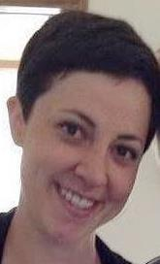
Nicole Ostrand (2015-2016 GGS)
GGS Rotary Area of Focus: Peace and Conflict Prevention/Resolution
Place of Study: University of Sussex, Brighton, United Kingdom
Studies & Degree: Doctorate in Migration Studies

Status (Fall 2019): Currently studying aboard at the University of Sussex in Brighton, England, supported by her Global Grant Scholarship. Nicole is pursuing a doctorate degree in migration studies. She anticipates completion of her degree program in the fall of 2019. Her Rotary “area of focus” is Peace and Conflict Prevention/Resolution.
I am passionate about helping people, I always have been. Over the last six years I become especially interested in migrant and refugee issues. I am committed to empowering and promoting the rights of migrant and refugee populations around the globe. This is a particularly salient issue in the current political climate where fear and prejudices are rampant. It is more important than ever to provide thoughtful and humane analyses on how to ensure the basic security and rights of migrants and refugees are protected.

The Rotary International Global Grant Scholarship from District 6220 has given me the opportunity to pursue what I love and further my career dedicated to migrants and refugees. With this scholarship, I was able to start my doctorate degree in migration studies at the University of Sussex in the United Kingdom. This has provided me with countless opportunities to engage with and think critically about this topic. At the University of Sussex, I have had access to academics, seminars, conferences, courses and volunteer groups concerned with these issues. Being a Global Grant Scholar has also given me the opportunity to meet with former and current Rotary Scholars. This has been particularly fulfilling as it has allowed me to forge new relationships and share interests and experiences.
I truly love what I do, and I could not be happier to be where I am today. Getting doctorate degree is a blessing. The Global Grant Scholarship has been a tremendous support in helping me follow this dream.

Upon completion of her degree program she plans to work for a migration/human rights-based N.G.O or research institute with the goal of improving the living condition for vulnerable migrants and refugees.
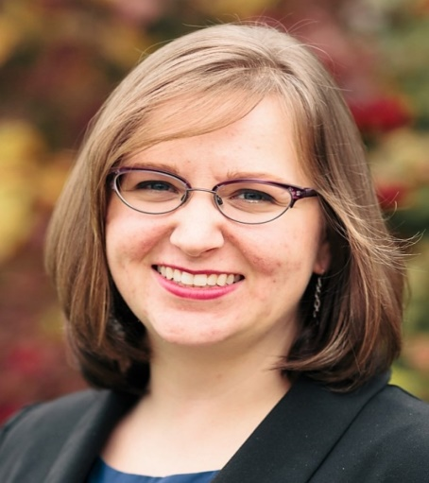
Paula K. Priebe (2017-2018 GGS)
GGS Rotary Area of Focus: Peace and Conflict Prevention/Resolution
Place of Study: University for Peace; Cuidad Colon, San Jose, Costa Rica
Studies & Degree: Master of Arts in International Peace Studies

Status (2018): Currently studying aboard at the University for Peace, San Jose, Costa Rica, supported by her Global Grant Scholarship. Paula is pursuing a master’s degree in International Peace Studies. Her Rotary “area of focus” is Peace and Conflict Prevention/Resolution.
I am currently working toward a Master of Arts in International Peace Studies degree at the United Nations-mandated University for Peace in Costa Rica. The Rotary Global Grant Scholarship is the reason that I am able to be here right now. It is a wonderful program and I encourage all interested, qualified persons to apply.
My background is in Urban Planning and international volunteering. However, I was feeling the desire to go back to school and shift my career focus. That can be challenging; leaving a career to pursue something different. However, working with Rotary, I am supported in my endeavors and have the financial freedom to take time to return to school. It has also been a blessing to have the comradeship of two fellow Global Grant scholars at my school and the support of a local Rotary Club here in Costa Rica.
The Rotary area of focus of my Global Grant is Peace and Conflict Prevention/Resolution. It aligns very closely with my chosen degree program. I hope to work in the field of post-conflict redevelopment after I complete my studies at UPeace, blending my background as an urban planner with my new focus of international peace studies.

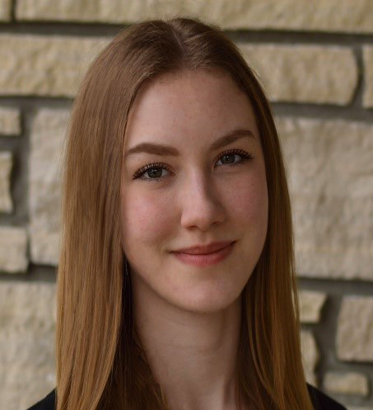
Anna K. DeWitt (2019-2020 GGS)
GGS Rotary Area of Focus: Peace and Conflict Prevention/Resolution
Place of Study: Queen’s University Belfast, Northern Ireland, United Kingdom
Studies & Degree: Master of Arts in Conflict Transformation and Social Justice

Anna K. DeWitt has completed her graduate program in 2020 and extended stay volunteer and part time work in 2021. She returned to her home town of Appleton, WI, in the spring of 2021 where she is now actively pursuing full time employment is her area of focus.

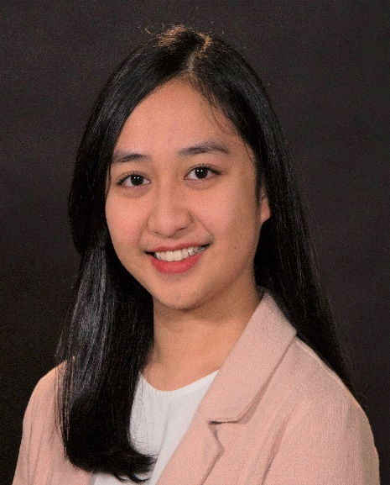
Keyla V. Higa (2020-2021) GGS
GGS Rotary Area of Focus: Peace and Conflict Prevention/Resolution
Place of Study: Erasmus University Rotterdam, Rotterdam, The Netherlands
Studies & Degree: Master of Science in Governance of Migration & Diversity

Keyla V. Higa is currently completing her Erasmus University Rotterdam (the Netherlands) graduate program thesis work which she expects to complete by late fall 2021. She has already begun but will pursue in earnest the search for a job in her field when she returns to the US.

